Nama : Muhammad Renaldi Maulana

NIM : 10122002

Kelas : IF-1

Link Website : [klik disini](https://reyn12.github.io/visualisasi-data-kbvd/)

Link Repository : [klik disini](https://github.com/Reyn12/visualisasi-data-kbvd)

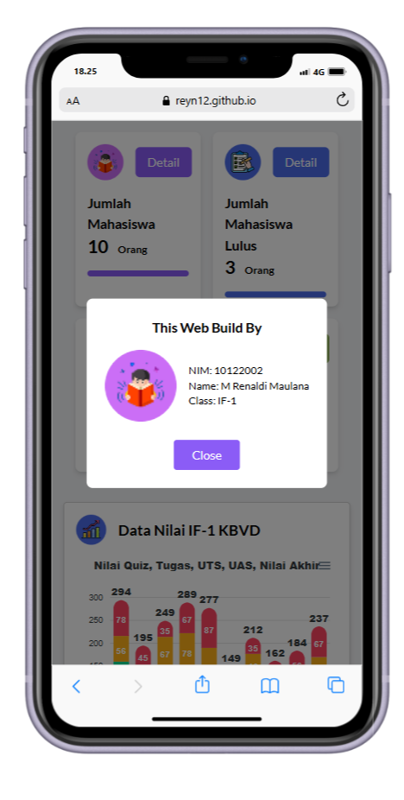Tampilan Website

